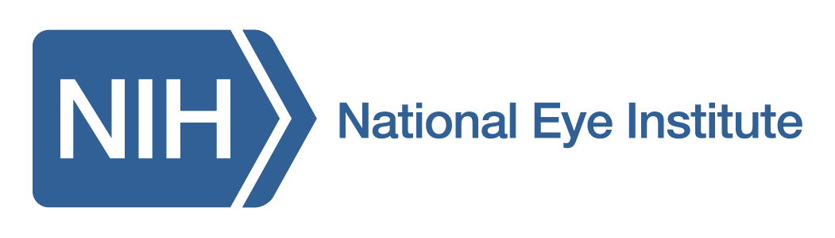

Postdoctoral fellowships in Metabolic Regulation of Development,
Aging and Neurodegeneration

We are looking for outstanding candidates with a PhD or MD/PhD (completed within the last two years) in any area of biology and excellent publication record to pursue innovative studies in retinal health and disease with a focus on RNA biology, epigenome, mitochondria and metabolism. Applicants with proven experience in biochemistry, developmental, cell and molecular biology or genetics will be preferred. Previous involvement in vision research is not essential. Successful fellows will have a strong passion to conduct independent scientific research and possess excellent communication and interpersonal skills. Annual stipend will be commensurate with experience and training.

For more information, visit https://nei.nih.gov/research/research-labs-and-branches/neurobiology-neurodegeneration-repair-laboratory.

Interested applicants should submit a cover letter with career goals, potential research projects of interest, curriculum vitae with publications, and contact information of three references to Anand Swaroop, Ph.D., Senior Investigator and Chief, NNRL/NEI/NIH at swaroopa@nih.gov

The NIH is dedicated to building a diverse community in its training and employment programs. DHHS, NIH, and NEI are Equal Opportunity Employers.

